# COMPUTER SCIENCE & ENGINEERING



**CHANDIGARH UNIVERSITY**

**UNIVERSITY INSTITUTE OF ENGINEERING**

**DEPARTMENT OF COMPUTER SCIENCE AND ENGINEERING**



|  |  |
| --- | --- |
| **Submitted by:** | **Submitted To:** Ajay Kumar (E13141) |
| **Subject Name:** | Machine Learning Lab |
| **Subject Code:** | 20CSP-317 |
| **Branch:** | CSE |
| **Semester:** | 5th |

LAB INDEX

|  |  |  |  |  |  |  |  |
| --- | --- | --- | --- | --- | --- | --- | --- |
| Sr.  No | Program | Date |  | Evaluation | | | Sign |
| LW  (12) | VV  (8) | FW  (10) | Total (30) |
| 1. |  |  |  |  |  |  |  |
| 2. |  |  |  |  |  |  |  |
| 3. |  |  |  |  |  |  |  |
| 4. |  |  |  |  |  |  |  |
| 5. |  |  |  |  |  |  |  |

# 

Experiment – 3.2

**Aim:** Implementation of Principal component Analysis.

**Objective:** To prepare a model with Principal component Analysis.

**Data Set Chosen:** Principal component Analysis

**Result and output:**

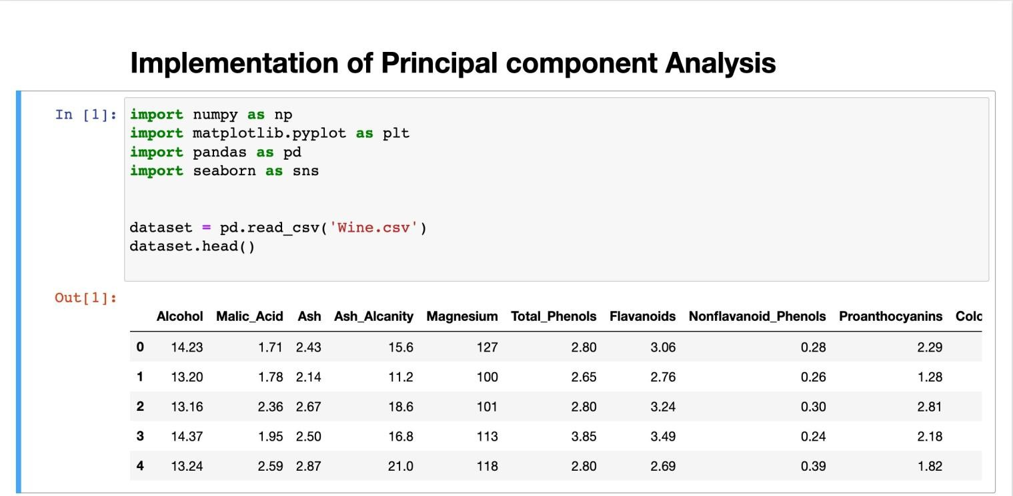

# COMPUTER SCIENCE & ENGINEERING



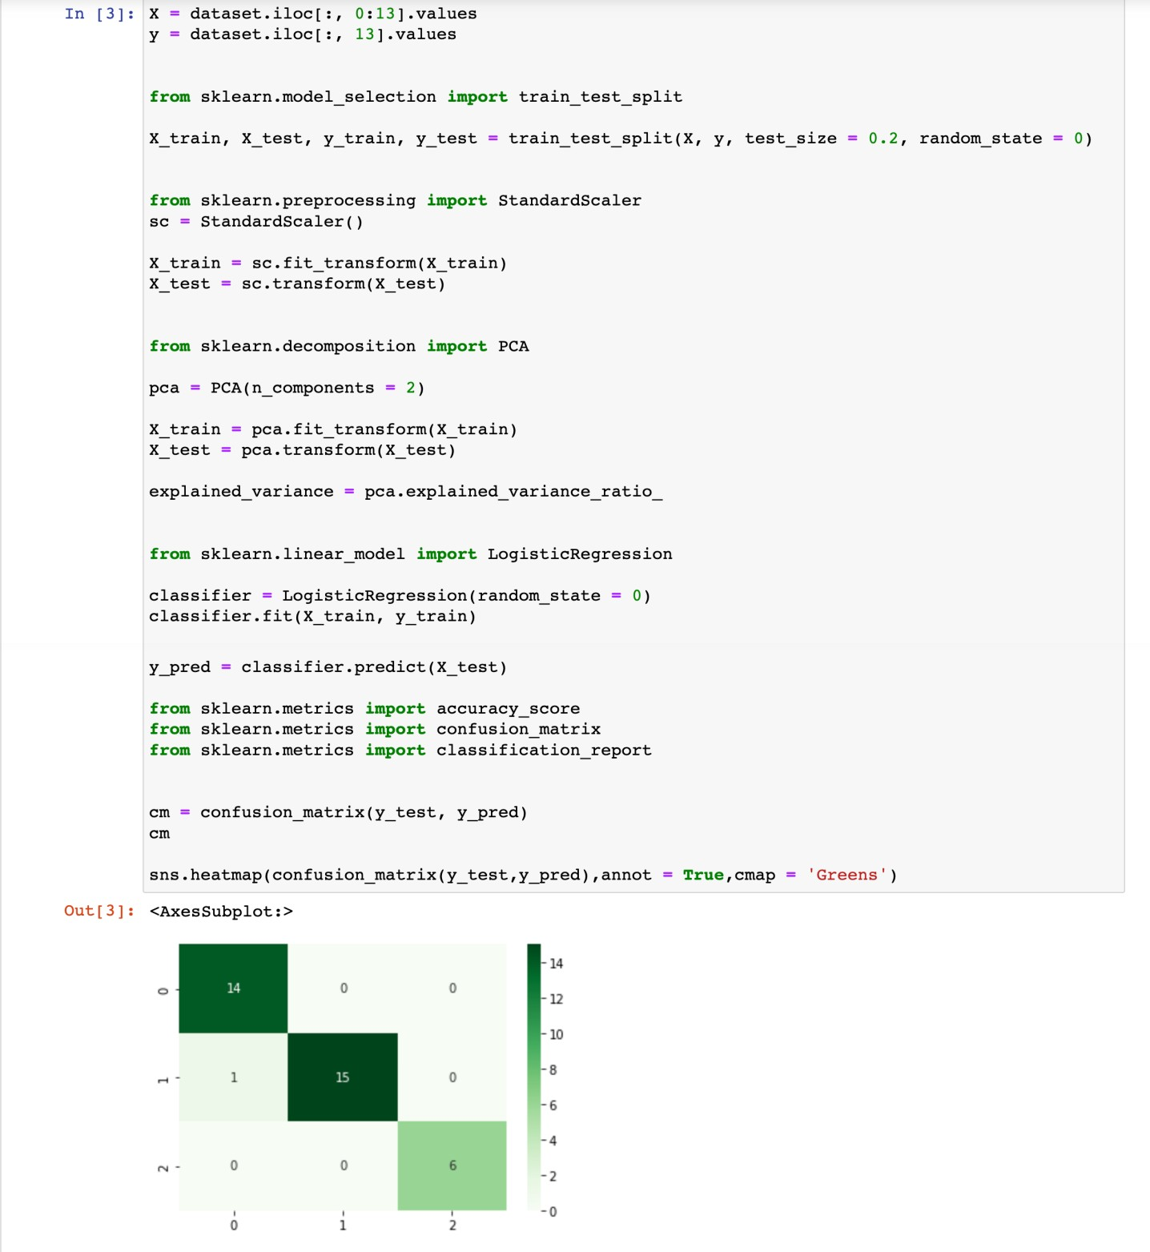

COMPUTER SCIENCE & ENGINEERING



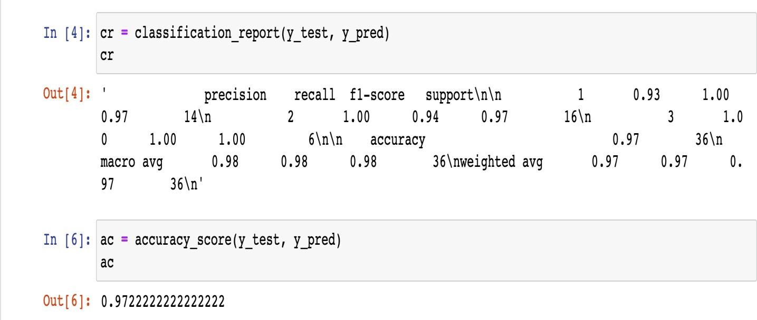

**Result: Accuracy of the model is approximately 97%.**